Module 02 Web Development, Design and Version Control

You will submit this with your guided exploration.

Use headings to organize topics and create a table of contents to be able to quickly access information. Here is how to add headings and subheadings:

* [Headings, Subheadings, and Table of Contents (Google Docs)](https://guides.lib.uni.edu/c.php?g=1243498&p=9758563)
* [Headings, Subheadings, and Table of Contents (Microsoft Word)](https://guides.lib.uni.edu/c.php?g=1243498&p=9207893)

As you add new headings to organize your documentation, refresh the table of contents below.

| General Resources  Web Development  HTML  Overview of HTML  HTML Attributes and Comments  CSS Basics  Bootstrap  Version Control  Web Accessibility and Inclusive Design |
| --- |

Make your own technical documentation to help you learn and have resources to help you on your projects.

| **DOs and DON’Ts** |
| --- |
| DO: Provide clear and simple explanations in your own words (be concise)   * Use short sentences, small paragraphs * Use lists and tables to organize information * Use standard industry terms but explain in simple language   **DON’T copy my explanations from the slides as yours.** |
| DO Use Code Snippets and Visuals to reduce lengthy explanations:   * Include code examples you created * Include comments to describe parts of your code * Include Screenshots, GIFs, Images   **DON’T use my slides as your image**  **DON’t copy my code examples** |
| DO Include Resources that give steps or help explain concepts   * You can include resources given in the lecture or find your own but   + Include website link with summary   + Include links to videos with summary of content |
| DO Use AI to help you learn   * Ask questions to understand concepts better, give examples for it to explain in simple terms, ask for AI to provide different examples * Ask AI for resources so you can cite and provide AI Tool Name and include the URLs to the main resources that helped you * Summarize in your own words and include * Use AI to create images that you describe   **DON’t**  use AI to create your technical documentation. |

# General Resources

Here you can list general resources that you use frequently for this module. Add other general resources to quickly get help on topics in this module.

* Class Resources[M02 Web Development and Inclusive Design](https://drive.google.com/drive/folders/1FSCmM7-ftSkk0hlosgoMjCjSV4w7GuVn)
* [HTML Tutorial](https://www.w3schools.com/html/default.asp)
* [Add a resource that helps you with CSS]
* [Add a resource that helps you with Bootstrap]
* [Add a resource that helps you with Git]
* [Add a resource that helps you with GitHub]

You will also add resources to more detailed examples in each section below.

# Web Development

## HTML

Here are examples of technical documentation to help you get started.

Notice how I didn’t copy and paste from lecture, created new examples and used highlighting, screenshots and images.

1. I create a heading 3 for the Overview of HTML and updated the table of contents
2. I highlighted examples to help understand vocabulary for start tag and end tag
3. Included a link and screenshot from a web page to understand HTML page structure. I updated the link with the title and not just a URL.
4. I created a table that was shaded to include a code example

### Overview of HTML

HTML provides structure for a web page using elements. Most elements have a start and end tag.

Here is an example of the heading 1 element

<h1>My Top Heading</h1>

<h1> is the start tag

</h1> is the closing tag

My Top Heading is the content to be displayed as a heading on the webpage

[Introduction to HTML](https://www.w3schools.com/html/html_intro.asp) explains the structure of a web page and HTML elements.

Here is the basic structure of a web page. The content visible on a web page goes in the body.

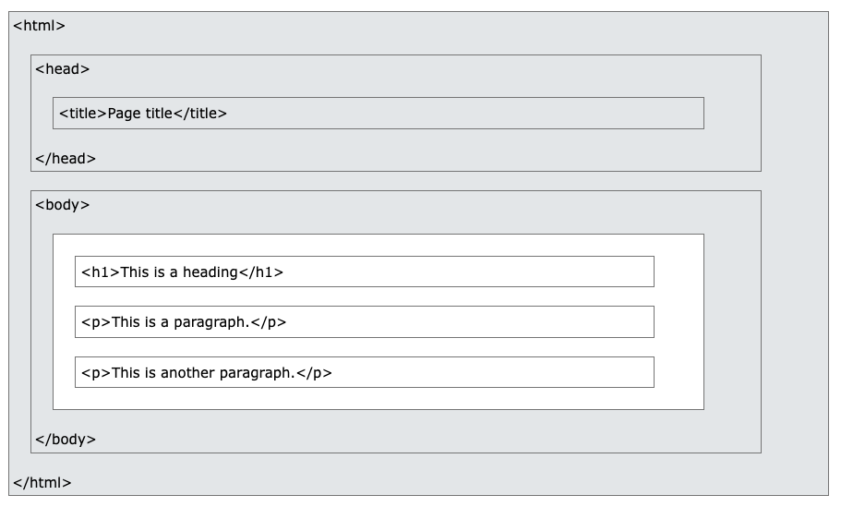

Example of an HTML web page created using [My First Heading](https://www.w3schools.com/html/tryit.asp?filename=tryhtml_elements)

| <!DOCTYPE html>  <html>  <body>  <h1>HTML</h1>  <p>HTML elements are structured to build a web page</p>  <h2>Headings</h1>  <p>You can add different sized headings from h1 to h6</p>  </body>  </html> |
| --- |

### HTML Attributes and Comments

Add content

Attributes is extra information about elements. It can add links, images, comments, new heading and lists.

For GIF

<!DOCTYPE html>

<html>

<head>

<title>THE LEGO MOVIE SCRIPT</title>

</head>

<body>

<h1>My First Heading</h1>

<p>My first paragraph.

YOOO HOO</p>

<gif

src="https://media1.tenor.com/m/HSxxt1scQXYAAAAC/cat-hugs.gif"

alt="cat holding flowers saying dont worry i love you"

width="300" height="400"

</body >

<P>iM A CHAIR COME SIT ON ME (EMMIT)>

</html>

FOR LINK

<!DOCTYPE html>

<html>

<body>

<h2>The href Attribute</h2>

<p>HTML links are defined with the a tag. The link address is specified in the href attribute:</p>

<a href="https://democracy-hub.net"> Fight for democracy</a>

</body>

</html>

Add a heading 3 for HTML Lists then refresh the table of contents

Ul start the list and ends it

Li is where you put text

<!DOCTYPE html>

<html>

<body>

<h3>An Unordered HTML List</h3>

<ul>

<li>Coffee</li>

<li>Tea</li>

<li>Milk</li>

</ul>

<h3>An Ordered HTML List</h3>

<ol>

<li>Coffee</li>

<li>Tea</li>

<li>Milk</li>

</ol>

</body>

</html>

## 

## CSS Basics

Add content

Controls the color, font, size of text.

<div></div>

<h2>Resources</h2>

<ul>

<li> <a href="https://www.w3schools.com/html/default.asp">HTML Tutorial</a></li>

<li> <a href="https://www.w3schools.com/css/default.asp">CSS Tutorial </a></li>

<li> <a href="https://www.w3schools.com/bootstrap5/index.php">Bootstrap 5 Tutorial</a></li>

</ul>

Css basics is what changes the color of text, and how we organize a website.

## Bootstrap

Add content

Helps organzie and ass sspecial format

<body>

<div class="container p-5 my-5 bg-dark text-white">

<h1>Hello, GitHub!</h1>

<p>This is my first web page using version control with Git and GitHub. I forked a repository to create this. A fork

in Git is a personal copy of another user's repository that allows you to make changes without affecting the

original project.yayyyy.</p>

</div>

# Version Control

Add headings and content.

## Version control

Its a history of all the changes you have made to a code or all branches of it in case you need to go back to an older version. Its like our repos and when we hit a commit.

# Web Accessibility and Inclusive Design

Add headings and content.

## This allows people with disabilities to manage websites better

## Autism

Make sentences short and straight forward

Dont have high contrasting colors

## Low vision

Add contrasting colors with large readable text

## Screen readers

Make sentences easy for the readers to pronounce and alt descriptions for images